**Uncertainty and Probability Reasoning**

**1. Explain the assumption of the Markov Model**

The key assumption of a Markov model is the Markov property, which states that the future state of a system depends only on its current state and is independent of how the system arrived at its current state. In other words, the Markov property implies that the past states of the system are not relevant for predicting its future behaviour, given the current state.

The Markov property can be formally expressed as follows:

*P*(*Xn*+1​=*xn*+1​∣*Xn*​=*xn*​, *Xn*−1​=*xn*−1​,…,*X*1​=*x*1​)=*P*(*Xn*+1​=*xn*+1​∣*Xn*​=*xn*​)

Here, *Xn*​ represents the state of the system at time *n*, and the equation says that the probability of the system being in state *xn*+1​ at the next time step, given the entire history of states up to the current time step, is equal to the probability of being in state *xn*+1​ given only the current state *xn*​.

**Example: Weather Model**

Consider a simple weather model with two states: "Sunny" and "Rainy." The Markov property implies that the probability of the weather being sunny or rainy tomorrow depends only on the current weather, not on how the weather has been in the past.

Let's define the transition probabilities:

* If today is sunny, the probability of it being sunny tomorrow is 0.8, and the probability of it being rainy tomorrow is 0.2.
* If today is rainy, the probability of it being sunny tomorrow is 0.3, and the probability of it being rainy tomorrow is 0.7.

This can be represented as a transition matrix:

| Sunny Rainy

---------------------

Sunny|0.8 0.2

Rainy|0.3 0.7

**2. How does gradient descent control the learning rate?**  
Gradient descent is an optimization algorithm used to minimize the cost or loss function in machine learning models during the training process. The learning rate is a crucial hyperparameter in gradient descent, as it determines the size of the steps taken during the optimization. The learning rate influences how quickly or slowly the algorithm converges to the optimal solution.

Here's how the learning rate is controlled in gradient descent:

1. **Fixed Learning Rate:**
   * In the simplest form of gradient descent, a fixed learning rate is used throughout the entire training process. The learning rate is chosen in advance and remains constant during optimization.
   * While easy to implement, a fixed learning rate may lead to suboptimal convergence or slow convergence in some cases. If the learning rate is too small, the algorithm may take a long time to converge, and if it's too large, it might overshoot the optimal solution.
2. **Adaptive Learning Rate:**
   * To address the limitations of a fixed learning rate, adaptive learning rate methods have been developed. These methods adjust the learning rate during training based on the behavior of the optimization process.
   * A widely used adaptive learning rate algorithm is **Adam (Adaptive Moment Estimation)**, which not only adapts the learning rates for each parameter but also keeps track of the past gradients and their squared gradients. This allows Adam to dynamically adjust the learning rates based on the past information.

**3. What does parameter optimization mean in Machine Learning?**

Parameter optimization in machine learning refers to the process of finding the best set of hyperparameters for a machine learning model. Hyperparameters are external configuration settings that are not learned from the data but are set prior to the training process. They are crucial in determining the performance of a machine learning model and can significantly impact its ability to generalize well to new, unseen data.

Parameters are the internal variables that the machine learning model learns from the training data, such as weights in a neural network or coefficients in a linear regression model.

The process of parameter optimization involves searching through a space of possible hyperparameter values to find the combination that results in the best model performance.

The search space can be vast, and various optimization techniques are used to efficiently explore it.

**4. What is the conditional independence?**

Conditional independence is a concept in probability theory and statistics that describes the relationship between random variables. Two random variables are said to be conditionally independent given a third variable if, once the third variable is known or specified, the occurrence or value of one of the variables provides no information about the occurrence or value of the other variable.

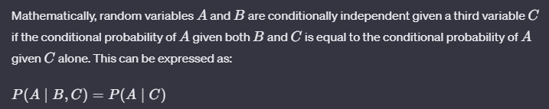

**5. Explain the posterior probability, likelihood and prior probability of the class with an example.**

In Bayesian statistics, the terms "prior probability," "likelihood," and "posterior probability" are fundamental components of Bayes' theorem, which is a mathematical formula that describes how to update probabilities based on new evidence. Let's break down these concepts with an example:

**Prior Probability (Prior):**

* The prior probability represents our initial belief or knowledge about the probability of an event before incorporating new evidence. It is denoted as *P*(*H*), where *H* is a hypothesis or an event.
* Example: Consider a factory that produces light bulbs. The prior probability of a light bulb being defective (*H*) before any testing might be based on historical data and is, for example, 0.05, indicating that 5% of the bulbs are typically defective.
* and is, for example, 0.05, indicating that 5% of the bulbs are typically defective.

**Likelihood:**

* The likelihood is the probability of observing the evidence given a certain hypothesis. It is denoted a *P*(*E*∣*H*), where *E* is the evidence.
* Example: If we test a light bulb and find that it is defective (*E*), the likelihood of this observation given the hypothesis that the bulb is defective (*H*) might be high, say 0.9. This means that defective bulbs are likely to be identified as defective during testing.

**Posterior Probability (Posterior)**

* The posterior probability is the updated probability of a hypothesis after considering the new evidence. It is calculated using Bayes' theorem and is denoted as *P*(*H*∣*E*), where *H* is the hypothesis, and *E* is the evidence.
* 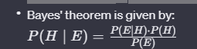
* Example: Using the above formulas, we can update the probability of a light bulb being defective (*H*) after observing that it is defective (*E*). The posterior probability *P*(*H*∣*E*) will depend on the prior probability *P*(*H*), the likelihood *P*(*E*∣*H*), and the overall probability of observing a defective bulb *P*(*E*).

**6. Explain the query variable, evidence and hidden variable**

In probabilistic graphical models, particularly in Bayesian networks, the concepts of query variables, evidence, and hidden variables play important roles. Let's break down these terms:

Consider a Bayesian network model designed to predict student performance in exams. The network includes the following variables:

1. **Query Variable (Q):**
   * Query variable represents what we want to know or predict. In this case, let's say the query variable is the probability of a student passing the final exam (Pass).
2. **Evidence Variables (E):**
   * Evidence variables are observed variables that provide information. For this example, evidence variables might include:
     + Study Hours (S): The number of hours a student spends studying.
     + Previous Exam Score (P): The score a student achieved on a previous exam.
3. **Hidden Variables (H):**
   * Hidden variables are not directly observed but might influence the observed variables. In this example, let's introduce a hidden variable:
     + Motivation (M): The motivation level of a student, which is not directly measurable but could influence both study hours and exam performance.

**Scenario:**

* Suppose we observe that a student has studied for 10 hours (*S*=10) and has a previous exam score of 80 (*P*=80). However, we don't directly know the student's motivation level (*M*).
* We want to query the probability of the student passing the final exam (*Pass*) given this evidence.

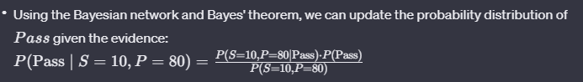

**Game Theory**

**1. Explain the “Zero Sum Game” in Artificial intelligence explain with a payoff matrix.**

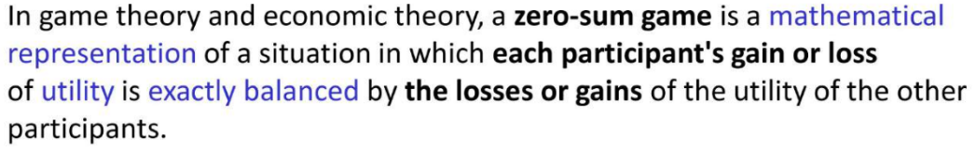



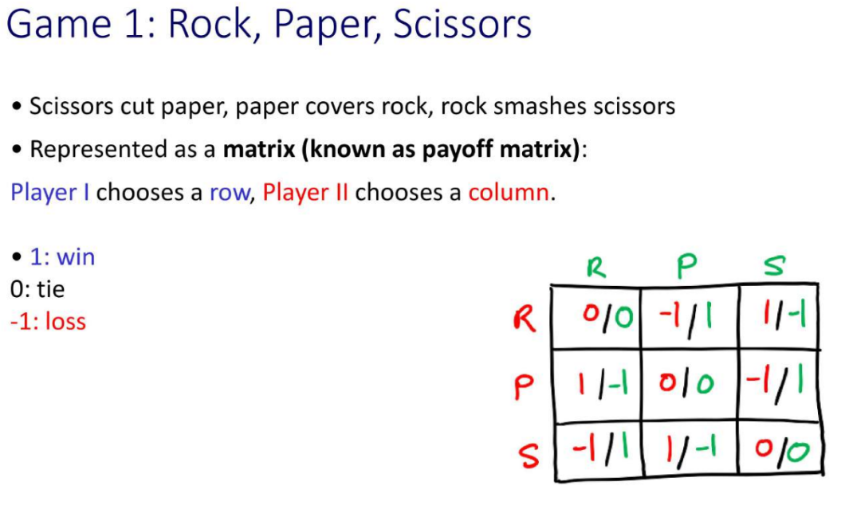

**2. Write down the concept of game theory also describe the algorithm of adversarial search**

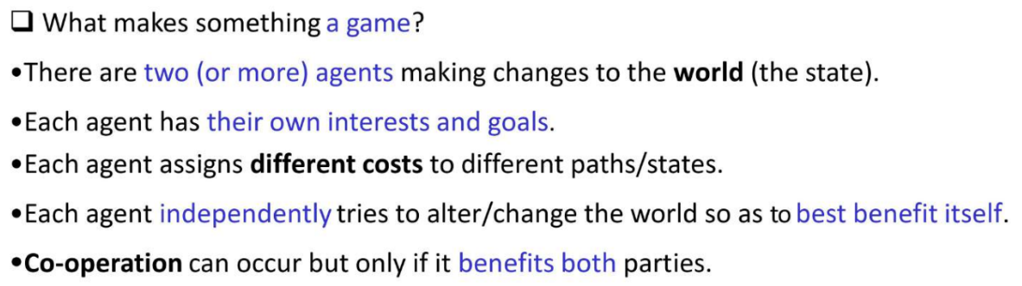



**3. Discuss the principle of game theory. Explain the mechanism of tic tac toe game.**



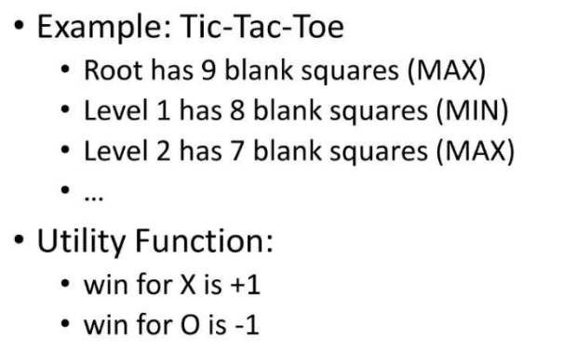

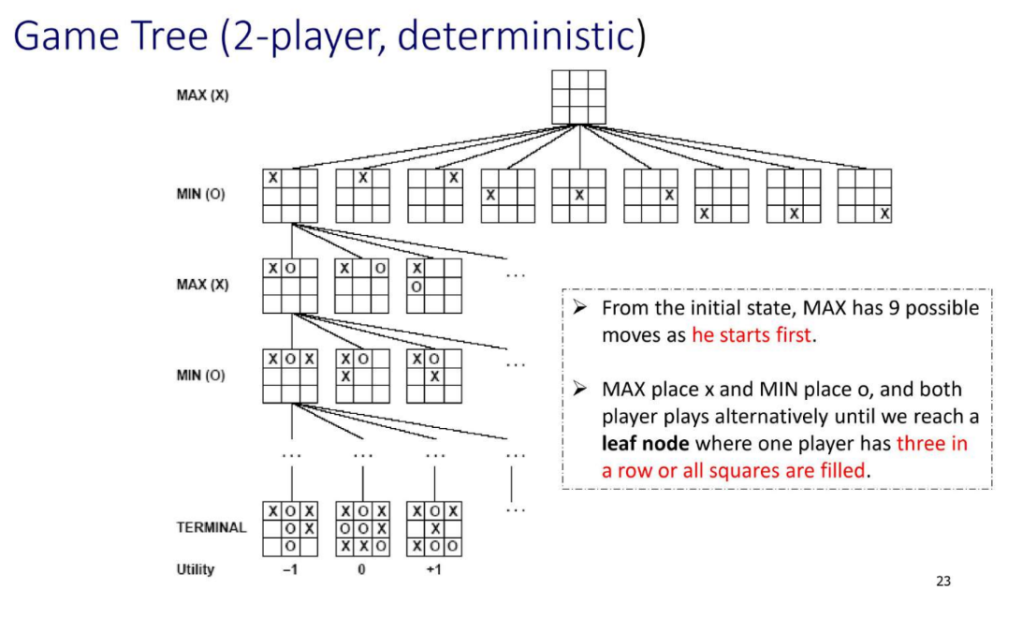

**KRR – Fuzzy Logic**

**1. What are hedges in Fuzzy logic? Illustrate how do hedges modify existing fuzzy sets?**



**2. Explain Fuzzy Modifiers with examples. Draw some standard fuzzy membership function**

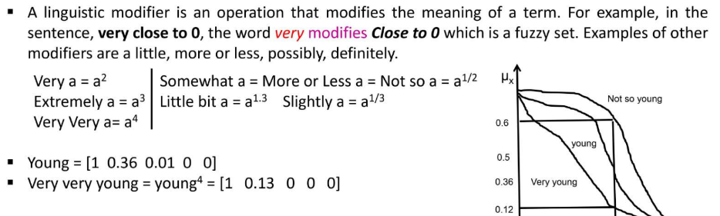

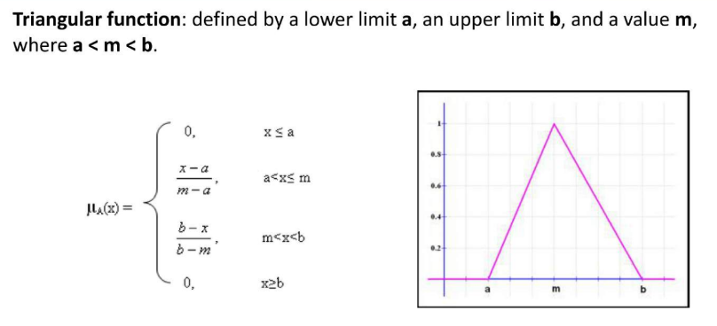

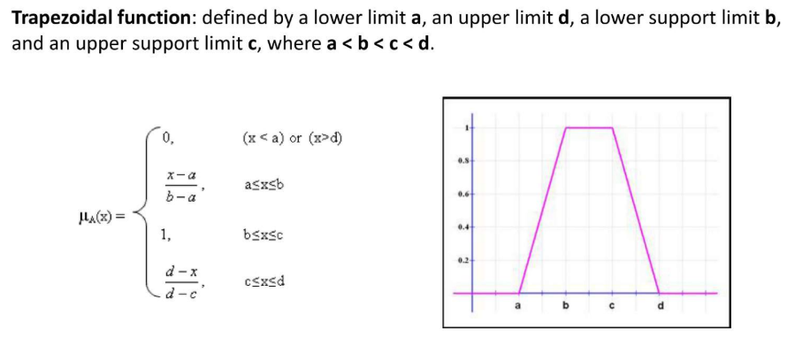

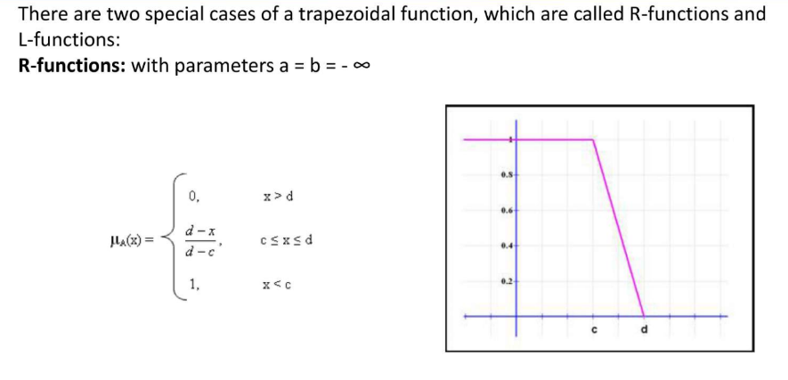

**ANN & BPNN**

**1. Difference between supervised and unsupervised learning.**

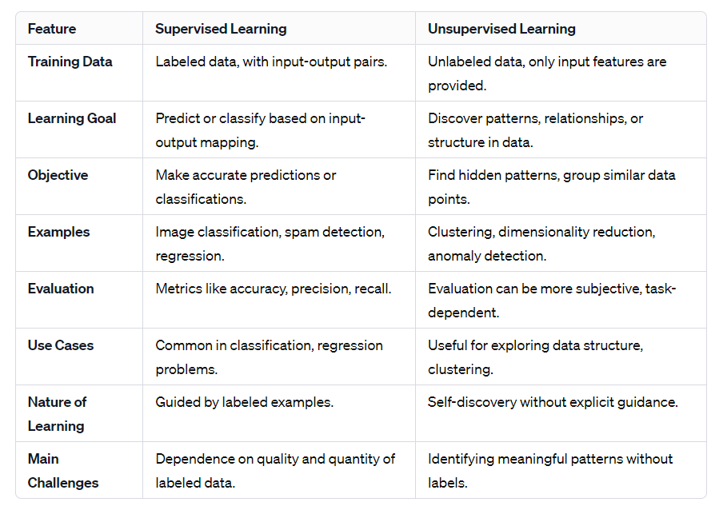

**2. Summarize the backpropagation learning process in your own word**

Backpropagation is a supervised learning algorithm used to train artificial neural networks. The process involves the following steps:

1. **Forward Pass:**
   * The input data is fed into the neural network, and the network processes this input through its layers to generate an output.
   * The output is compared to the actual target (ground truth) to calculate the error or the difference between the predicted and actual values.
2. **Backward Pass (Backpropagation):**
   * The error is propagated backwards through the network to update the weights of the connections between neurons.
   * Using the chain rule of calculus, the algorithm calculates the gradient of the error with respect to each weight in the network.
   * The weights are adjusted in the opposite direction of the gradient to minimize the error.
3. **Weight Update:**
   * The learning rate, a hyperparameter, determines the size of the step taken during weight updates.
   * The weights are updated using the calculated gradients, nudging them in the direction that reduces the error.
4. **Iteration**:
   * Steps 1-3 are repeated for multiple iterations (epochs) until the model converges to a state where the error is minimized.
   * The training process aims to find the optimal set of weights that allows the neural network to make accurate predictions on new, unseen data.

**3. What does parameter optimization mean in a machine learning model?**

Parameter optimization, often referred to as hyperparameter tuning, is the process of finding the best set of hyperparameters for a machine learning model to achieve optimal performance.

Here are some key points related to parameter optimization:

1. **Hyperparameters:**
   * Hyperparameters are external configuration settings for a model. They are not learned from the data but are set by the data scientist or machine learning practitioner.
   * Examples of hyperparameters include learning rate, regularization strength, the number of hidden layers in a neural network, and the number of decision trees in a random forest.
2. **Objective of Parameter Optimization:**
   * The goal of parameter optimization is to find the set of hyperparameters that maximizes the performance of the model on a specific task or dataset.
   * Performance metrics, such as accuracy, precision, recall, or F1 score, are used to evaluate the model's effectiveness.
3. **Search Space:**
   * The space of possible hyperparameter values is known as the search space. The goal is to search through this space efficiently to find the combination that results in the best model performance.
   * Different optimization techniques, such as grid search, random search, and more advanced optimization algorithms like Bayesian optimization, can be used to explore this space.

**4. How does gradient descent control/determine learning rate?**

Gradient descent is an iterative optimization algorithm used to minimize the cost or loss function in the training of machine learning models. The learning rate is a hyperparameter in gradient descent that determines the size of the steps taken during each iteration to update the model parameters.

Here's how gradient descent controls or determines the learning rate:

1. **Fixed Learning Rate:**
   * In some cases, a fixed learning rate is used throughout the entire training process. The choice of the learning rate is based on heuristics, experimentation, or prior knowledge of the problem.
   * A too-high learning rate can lead to overshooting the minimum, causing the algorithm to fail to converge or oscillate around the minimum. On the other hand, a too-low learning rate can result in slow convergence or getting stuck in local minima.
2. **Adaptive Learning Rate:**
   * To address the challenges of a fixed learning rate, adaptive learning rate methods dynamically adjust the learning rate during training based on the behaviour of the optimization process.
   * For example, Adam combines elements of both momentum and RMSprop, adjusting the learning rates individually for each parameter based on their historical gradients and squared gradients.

**5. Difference between supervised and re-inforcefement learning**

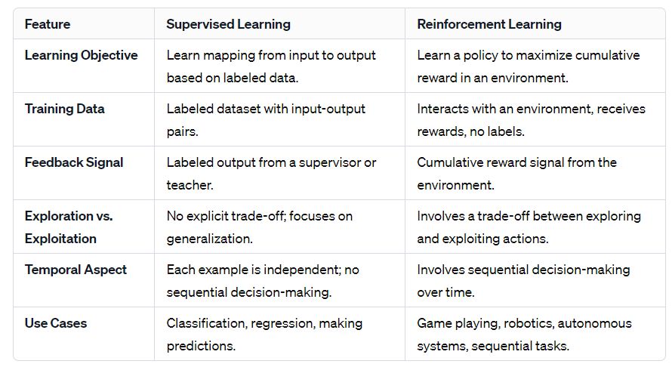

**Genetic Algorithm**

**1. Define Crossover and mutation with an example**

In the context of genetic algorithms, crossover and mutation are two fundamental operators used to evolve a population of candidate solutions over multiple generations.

**Crossover:**

Crossover, also known as recombination or mating, involves taking two parent solutions and combining their genetic information to create one or more offspring solutions. The idea is to simulate the process of genetic recombination that occurs in biological reproduction.

There are various methods for crossover, such as one-point crossover, two-point crossover, and uniform crossover. I'll explain one-point crossover with an example:

Parent 1: 0101101101010101

Parent 2: 1010010010111001

Crossover point: 7

Offspring 1: 0101101000111001

Offspring 2: 1010011111010101

In this example, the crossover point is at index 7. The genetic material before the crossover point is exchanged between the parents, resulting in two new offspring.

**Mutation:**

* Mutation involves making small random changes to one or more individuals in the population. It introduces genetic diversity into the population and prevents the algorithm from converging to a suboptimal solution. The mutation is applied with a low probability to avoid drastic changes to the population.
* Mutation can involve flipping a bit in a binary representation, changing a value in a numerical representation, or making other small alterations. Here's an example with a binary representation:

Example:

Original: 1100101

Mutation point: 4

Mutated: 1101101

In this example, a bit at position 9 is flipped, representing a small random change in the genetic material of the individual.

**2. Why Mutation is important?**

Mutation is important in genetic algorithms and other evolutionary optimization algorithms for several reasons:

**Maintaining Diversity:**

Mutation helps maintain genetic diversity within the population. Without mutation, the population might converge to a suboptimal solution because individuals with similar genetic makeup dominate the population.

**Exploration of New Solutions:**

* Mutation introduces novel genetic material into the population, allowing the algorithm to explore regions of the solution space that might not be reachable through crossover alone.

**Avoiding Local Optima:**

In optimization problems, especially in complex solution spaces with multiple local optima, mutation can help the algorithm escape from local optima. It introduces randomness, which can be crucial for moving the search away from suboptimal regions and toward more promising areas of the solution space.

**Adaptation to Changing Environments:**

* In dynamic optimization problems where the fitness landscape changes over time, mutation is essential for adaptation. New, potentially beneficial traits may become advantageous in a changing environment, and mutation allows the population to explore and adapt to these changes.

**Preventing Stagnation:**

Over successive generations, without mutation, a population may become homogeneous and stagnate. Mutation injects variability, preventing the population from becoming too uniform and facilitating ongoing exploration and improvement.